**Project Title: Weather Prediction using Machine Learning**

**Problem Description:**

The goal of this project is to develop a machine learning model that can predict weather conditions in advance. By leveraging historical weather data, the aim is to create a model that can forecast future weather patterns with high precision.

**Data Exploration:**

1. **Data Sources:**

The dataset utilized in this arrangement has been gathered from Kaggle which is “Historical Weather Data for Indian Cities” from which we have chosen the data for “Kanpur City”.

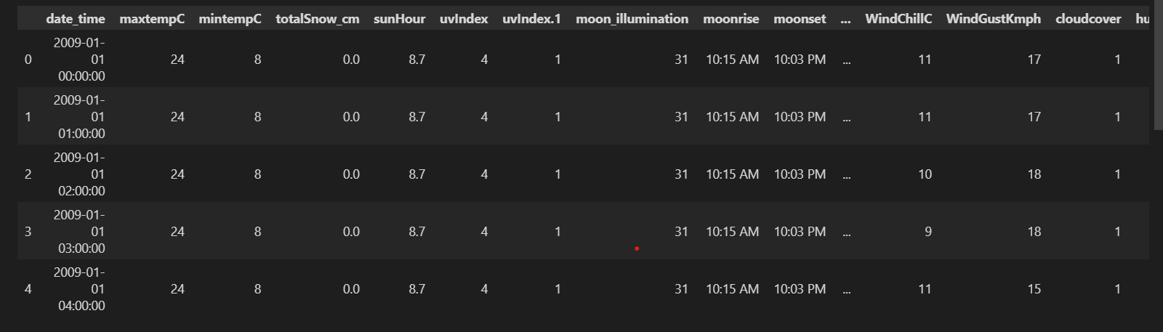

**Data Types of the data:**

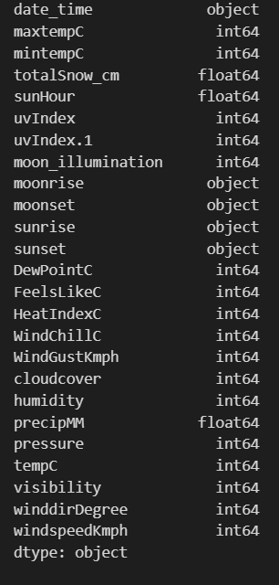

**Null values:**

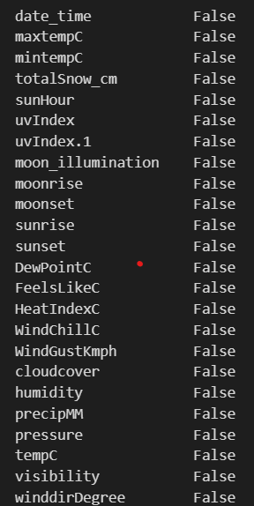

**Describe() method:**

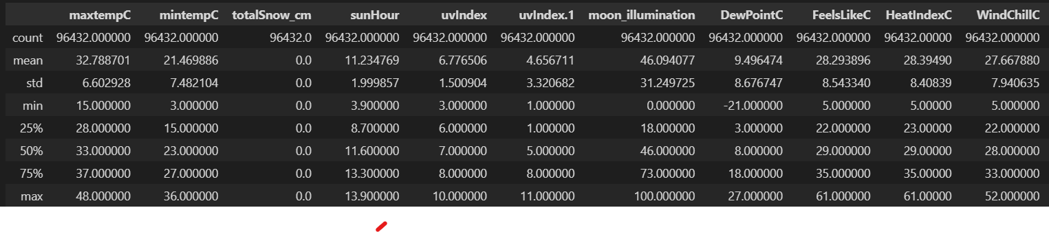

**Machine learning approach:**

Machine Learning Algorithm can be broadly classified into three types: Supervised Learning Algorithms Unsupervised Learning Algorithms Reinforcement Learning algorithm

There are various machine learning algorithms for the prediction like Linear regression, Decision Tree, Random Forest, Support Vector Machines, K-Means Clustering, Logistic regression.

Supervised learning is the types of machine learning in which machines are trained using well "labelled" training data, and on basis of that data, machines predict the output. The labelled data means some input data is already tagged with the correct output. Supervised learning can be used for regression tasks.

In this project, we are concentrating on the temperature prediction of Kanpur city with the help of various machine learning algorithms and various regressions. By applying various regressions on the historical weather dataset of Kanpur city we are predicting the temperature like first we are applying Multiple Linear regression, then Decision Tree regression, and after that, we are applying Random Forest Regression.

**Information about Data**:

There are 96432 rows in the data. The dataset utilized in this arrangement has been gathered from Kaggle which is “Historical Weather Data for Indian Cities” from which we have chosen the data for “Kanpur City”. The dataset was created by keeping in mind the necessity of such historical weather data in the community. The dataset was used with the help of the worldweatheronline.com API and the wwo_hist package. The datasets contain hourly weather data from 01-01-2009 to 01-01-2020. The data of city is for more than 10 years. This data can be used to visualize the change in data due to global warming or can be used to predict the weather for upcoming days, weeks, months, seasons, etc. The main target of this dataset can be used to predict the weather for the next day or week with huge amounts of data provided in the dataset. Furthermore, this data can also be used to make visualization which would help to understand the impact of global warming over the various aspects of the weather like precipitation, humidity, temperature, etc.